Deployment instructions:

To run the project you need:

- Ecplise

- Java

- MySQL database

Steps to configure the database:

Our project use following settings:

<property name=*"connection.username"*>developer</property>

<property name=*"connection.password"*>moppa_Dev</property>

<property name*="connection.url">*jdbc:mysql://localhost:3306/moppadb</property>

So to run it, you need to create in your MySQL database user with name “developer” and password “moppa_Dev” and create database schema “moppadb”.

Steps to run the project:

1. Downolad zipped project from github -> <https://github.com/elzbietaZ/moppa/tree/master>



And save it on your computer and unpack.

1. Open Eclipse
2. Click File -> Import -> Maven-> Existing Maven Projects
3. 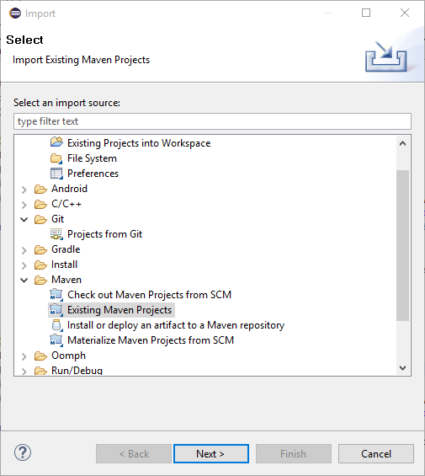
4. Choose the moppa project in directories browser
5. Select it and click Finish.
6. Project should appear in Eclipse, click it with right button and click Maven -> Update Project
7. Wait until all dependencies will be downloaded.
8. To run the server you need to run ServerSetup class.